

# Oppo Find X3 Lite 5G

## Type of device: Mobile

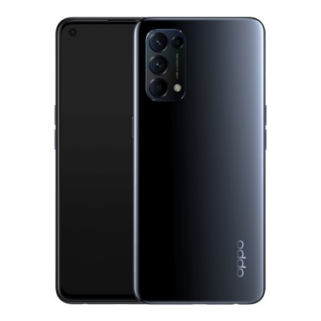

Actual Display Size : 6.4 inches

Button Type : Touchscreen

Operating System : Android

Version Number : ColorOS 11.1 (Based on Android 11)

Network Capability : 3G,4G,5G

Year of Release : 2021

Average Price : $747 as of 12 05 2021

## Accessibility Features:

### Cognitive

* Additional Instructions
* Copy and Paste
* GPS
* Photo Telephone List
* Screen Timeout Disabled
* Simple Instructions
* Simple Reminders
* Simplify Display

Voice Notes

### Hearing Impairment and Deaf

* Allows for sign language communication
* Bluetooth or Wi-Fi
* Closed Captioning
* Front Facing Camera
* Text Messaging/SMS
* Vibrating Alerts - Adjustable
* Video Communications - Two-way

Visual Alerts - Incoming Calls

### Vision

* Battery Alert - Audible
* Bluetooth or Wi-Fi
* Brightness Adjustable
* Dictation / Speech-to-Text
* High Contrast Mode
* Personalised Shortcuts
* Power Cue
* Screen Magnifier
* Screen Reader
* Text Size Adjustable
* Voice Control /Personal Assistant

Voiced Menus

### Speech

* Allows for sign language communication
* Bluetooth or Wi-Fi
* Messaging Options - Email
* Messaging Options - IM
* Messaging Options - MMS
* Predictive Text

SMS Personalisation and Reuse

### Physical

* Bluetooth or Wi-Fi
* Dictation / Speech-to-Text
* Gesture Based Navigation
* Headset - plug connected
* Predictive Text
* Speaker-phone option
* Switch control option
* Voice Control / Personal Assistant
* Voice Recognition for Accessing Features

Voice Recognition for Dialling

## How and where to get it from?

You can buy this phone from [Optus](https://www.optus.com.au/mobile/phones/oppo/find-x3-lite-5g?SID=con:deals:desktop:apr21:postmob:OppoFindx3Lite:), [Officeworks](https://www.officeworks.com.au/shop/officeworks/p/oppo-find-x3-lite-8gb-128gb-starry-black-oppx3ltebk), [Harvey Norman](https://www.harveynorman.com.au/oppo-find-x3-lite-5g-128gb-starry-black.html), [JB Hi-Fi](https://www.jbhifi.com.au/products/oppo-find-x3-lite-5g-128gb-astral-blue), [Woolworths](https://mobile.woolworths.com.au/Flexi-Mobile-Plans/smartphone/OPPO-Find-X3-Lite-5G/p/OPPOFINDX3LITE5G), [Mobileciti](https://www.mobileciti.com.au/oppo-find-x3-lite-5g), and other retailers.

## More information is available on:

[Oppo Find X3 Lite Webpage](https://www.oppo.com/au/smartphones/series-find-x/find-x3-lite/#link.button-buy)

[Oppo Find X3 Lite Specifications](https://www.oppo.com/au/smartphones/series-find-x/find-x3-lite/specs/)

[Oppo Find X3 Lite User Manual (PDF Download)](https://ipics.oppo.com/oppo_nl/answer/ColorOS_11.1_User_Guide_V1.1.pdf)